Assembly Examples

USMAN BASHARAT

00874782

TASK 0 - Using the grey IDC10 ribbon cable (DO NOT USE THE RAINBOW RIBBON CABLE)

* Check that all the boxes have the IDC connections with the the notch facing inwards, as shown for the switch light box diagram above. (Sometime these connections pull out and are incorrectly reinserted back to front)
* 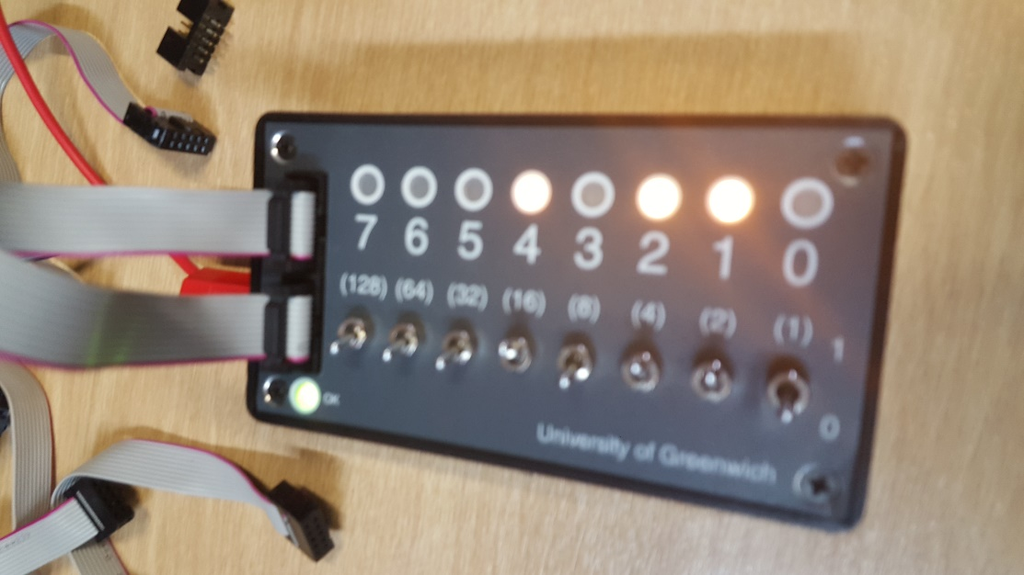How to Test IDC cables. Connect the switch light box's switches to the switch light box's LED's. There should be a one to one relationship of the switch to the LED above it. If there is not, or some LEDs do not illuminate, then normally the cable is at fault.
* Connect the switch light box's switches to the 'Traffic Lights' interface box and note the relationship of switches to the traffic light's LEDs0020

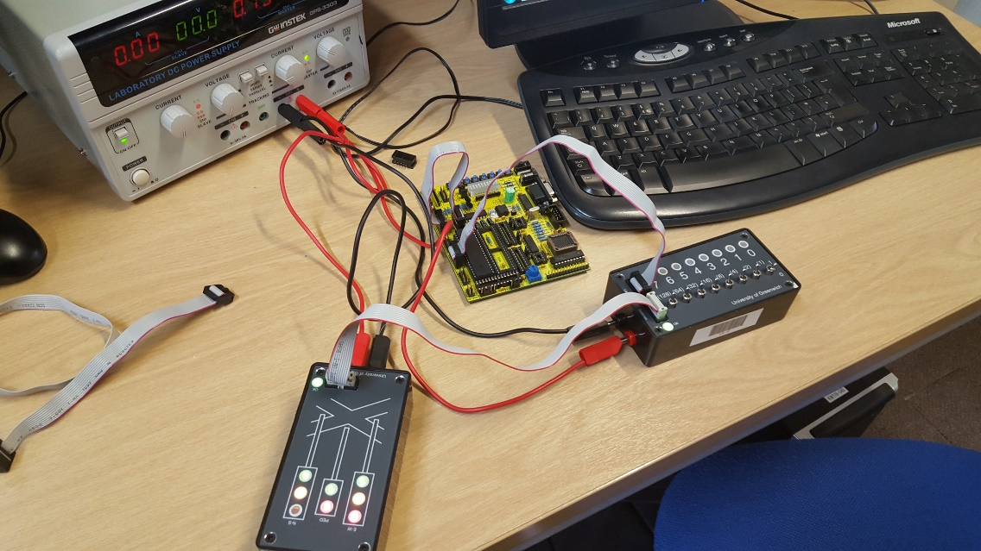

* 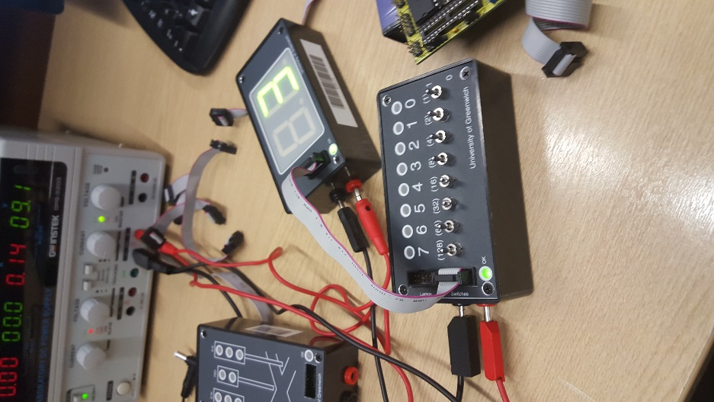Connect the switch light box's switches to the 'Dual Seven Segment Display' interface box and note the relationship of switches to the seven segment display's segments.
* Connect the STK200's on board push buttons to the switch light box's LEDs and note the relationship of the on board buttons to the switch light box's LEDs.

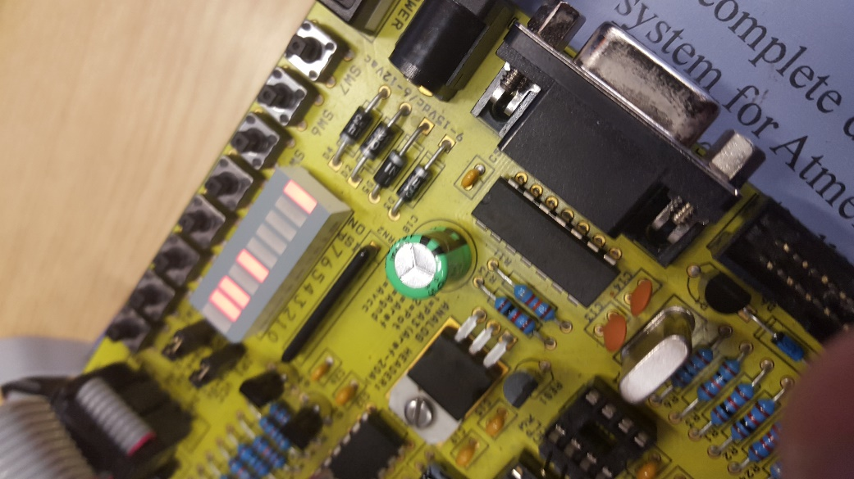

* Connect the switch light box's switches to the STK200's on board LEDs and note the relationship of switches to the LEDs

Task 1

;Program to output 55 hexadecimal to ports B and port C

.equ PORTA =$1B ;Port A Output Address

.equ DDRA =$1A ;Port A Data Direction Register Address

.equ PINA =$19 ;Port A Input Address

.equ PORTB =$18 ;Port B Output Address

.equ DDRB =$17 ;Port B Data Direction Register Address

.equ PINB =$16 ;Port B Input Address

.equ PORTC =$15 ;Port C Output Address

.equ DDRC =$14 ;Port C Data Direction Register Address

.equ PINC =$13 ;Port C Input Address

.equ PORTD =$12 ;Port D Output Address

.equ DDRD =$11 ;Port D Data Direction Register Address

.equ PIND =$10 ;Port D Input Address

;Program Initialisation

;Initialise output ports

ldi r16,$ff

out DDRB,r16 ;Set Port B for output by sending $FF to direction register

out DDRC,r16 ;Set Port C for output by sending $FF to direction register

;Main Program

;Output $55 to Port B and Port C

main: ldi r16,$F0 ;Load 55 hex into r16

out PORTC,r16 ;Output 55 hex to Port C

out PORTB,r16 ;Output 55 hex to Port B

rjmp main ;Repeat forever

Calculation

Just add all the clocks up as shown. Adding them equals towards 8

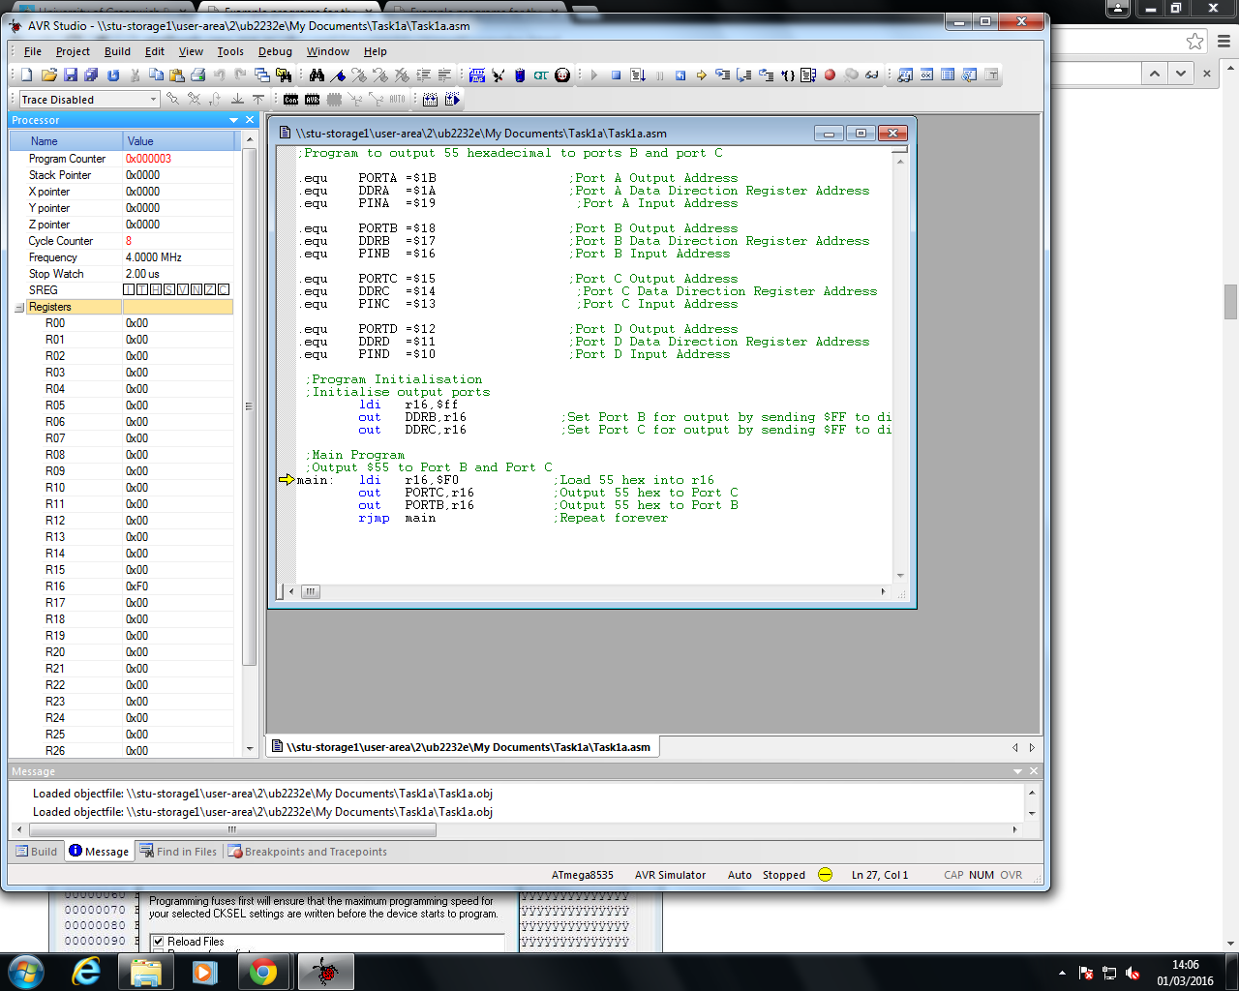

Task 2

;Program to echo the switches attached port A to ports B and C

;Program to echo the switches attached port A to ports B and C

;Port Addresses

.equ PORTA =$1B

.equ DDRA =$1A

.equ PORTB =$18

.equ PINB =$16

.equ PORTC =$15

.equ PINC =$13

.equ PORTD =$12

.equ DDRD =$11

;Register Definitions

.def temp =r16 ;Temporary storage register

;Program Initialisation

;Initialise Input Ports

ldi temp,$00

out PORTC,temp ;Set Port A for input by sending $00 to direction register

out PORTB,temp

; Initialise output ports

ldi temp,$FF ;Set Port C for output by sending $FF to direction register

out DDRA,temp

out DDRD,temp

; Main Program

loop: in r17,PINC

in r18,PINB

out PORTD,r17

out PORTA, r18

rjmp loop Task 3

chase2.asm

;Program to sequence LEDs on port C with delay loop

;Port Addresses

.equ PORTC =$15 ;Port C Output Address

.equ DDRC =$14 ;Port C Data Direction Register

;Register Definitions

.def leds =r0 ;Register to store data for LEDs

.def temp =r16 ;Temporary storage register

;Program Initialisation

;Initialise output ports

ldi temp,$ff

out DDRC,temp ;Set Port C for output by sending $FF to direction register

;Initialise Main Program

sec ;Set carry flag to 1

clc leds ;Clear LEDs

;Main Program

forever: out PORTC,leds ;Display LEDs to port C

;delay section of code (25.344 ms @ 1MHz) - utilises r25,r24

ldi r24,$C4 ;Initialise 2nd loop counter

loop2: ldi r25,$FF ;Initialise 1st loop counter

loop1: dec r25 ;Decrement the 1st loop counter

brne loop1 ;and continue to decrement until 1st loop counter = 0

dec r24 ;Decrement the 2nd loop counter

brne loop2 ;If the 2nd loop counter is not equal to zero repeat the 1st loop, else continue

;end of delay section of code

rol leds ;Rotate LEDs left by 1 bit through carry flag

rjmp forever

Calculation Delay

1+[(255 \* 3) – 1] = 765 one loop

1+765\*255 + (255-1)\*3+2 = 195840 maximum delay possible using two nested loops

195840/100000 = 195.840ms delay

Task 4

Using three loops

1+(255-1)\*3+2=765

1+195840\*255+(255-1)\*3+2 = 49939965

4993965/1000000 = 49.939965s so 49.94s

Delay for 1.175s

1+(255-1)\*3+2=765

1+765\*255+(255-1)\*3+2 = 195840

1+195840\*6+(6-1)\*3+2 = 1175058s

1175058s/1000000 = 1.175058s so 1.175s

TASK 5- Attach the switch light box's LEDs to Port C.

* Calculate the maximum delay possible with this technique  @ 1 MHz clock frequency. (Answer 262.141 ms)
* Alter 'chase 4' so the delay is 150 ms.

Demonstrate the program to the tutor and upload the program, flow chart and delay calculations to your logbook.

(3\*255)+(3\*255\*255)+(3\*255\*255\*255)+(3\*255\*255\*255\*255) = 12734691840 micro seconds

150000/4=37500= $927C

;Program to sequence LEDs on port C using a delay subroutine

;Status Register Address

.equ SREG =$3F ;Status Register Address

;Stack and Stack Pointer Addresses

.equ SPH =$3E ;High Byte Stack Pointer Address

.equ SPL =$3D ;Low Byte Stack Pointer Address

.equ RAMEND =$25F ;Stack Address

;Port Addresses

.equ PORTC =$15 ;Port C Output Address

.equ DDRC =$14 ;Port C Data Direction Register Address

;Register Definitions

.def leds =r0 ;Register to store data for LEDs

.def temp =r16 ;Temporary storage register

.def save =r19 ;Temporary storage register for status register

.def YL =r28 ;Define low byte of Y

.def YH =r29 ;Define high byte of Y

;Program Initialisation

;Set stack pointer to end of memory

ldi temp,high(RAMEND)

out SPH,temp ;Load high byte of end of memory address

ldi temp,low(RAMEND)

out SPL,temp ;Load low byte of end of memory address

;Initialise output ports

ldi temp,$ff

out DDRC,temp ;Set Port C for output by sending $FF to direction register

;Initialise Main Program

sec ;Set carry flag to 1

clr leds ;Clear LEDs

;Main Program

forever: out PORTC,leds ;Display leds to port C

rcall delay ;Call delay subroutine

rol leds ;Rotate leds left by 1 bit through carry flag

rjmp forever ;Continue forever

;Delay Subroutine (25.351 ms)

delay: in save,SREG ;Preserve status register

ldi YH,high($927C) ;Load high byte of Y

ldi YL,low($927C) ;Load low byte of Y

loop: sbiw Y,1 ;Decrement Y

brne loop ;and continue to decrement until Y=0

out SREG,save ;Restore Status register

ret ;Return

TASK 6- Attach the switch light box's LEDs to Port C and the switch light box's switches to Port A

* Alter 'chase 5' so instead of the poll being on the MSB on port A, make the poll the Least Significant Bit (LSB) on port A - i.e. switch 0 on the switch light box . Note - operating switches 7 to 1 on the switch light box should not affect the program. Hint - reflect on subnet masks from the networking course.

;Program to sequence LEDs on port C, uses the MSB on switches to change direction

;Stack and Stack Pointer Addresses

.equ SPH =$3E ;High Byte Stack Pointer Address

.equ SPL =$3D ;Low Byte Stack Pointer Address

.equ RAMEND =$25F ;Stack Address

;Port Addresses

.equ DDRA =$1A ;Port A Data Direction Register Address

.equ PINA =$19 ;Port A Input Address

.equ PORTC =$15 ;Port C Output Address

.equ DDRC =$14 ;Port C Data Direction Register Address

;Register Definitions

.def leds =r0 ;Register to store data for LEDs

.def temp =r16 ;Temporary storage register

.def chdir =r20 ;Register determining sequence direction of LEDs

;Program Initialisation

;Set stack pointer to end of memory

ldi temp,high(RAMEND)

out SPH,temp ;Load high byte of end of memory address

ldi temp,low(RAMEND)

out SPL,temp ;Load low byte of end of memory address

;Initialise Input Ports

ldi temp,$00

out DDRA,temp ;Set Port A for input by sending $00 to direction register

;Initialise Output Ports

ldi temp,$ff

out DDRC,temp ;Set Port C for output by sending $FF to direction register

;Initialise Main Program

sec ;Set carry flag to 1

clr leds ;Clear leds

;Main Program

forever: out PORTC,leds ;Display leds to port C

rcall delay ;Call delay subroutine

rcall pollswt ;Poll switches to check direction change

bst chdir, 0 ;Test if negative

brts right ;If switch 7= 1 chase right else if if switch 7 = 0 chase left

;Rotate leds left

left: rol leds ;Rotate leds left by 1 bit through carry flag

rjmp forever

;Rotate leds right

right: ror leds ;Rotate leds right by 1 bit through carry flag

rjmp forever

;Polling Subroutine

pollswt: in chdir,PINA ;Read switches on switch light box

ret

;delay section of code (25.348 ms @ 1MHz) - utilises r25,r24

delay: ldi r24,$21 ;Initialise 2nd loop counter

loop2: ldi r25,$FF ;Initialise 1st loop counter

loop1: dec r25 ;Decrement the 1st loop counter

brne loop1 ;and continue to decrement until 1st loop counter = 0

dec r24 ;Decrement the 2nd loop counter

brne loop2 ;If the 2nd loop counter is not equal to zero repeat the 1st loop, else continue

ret ;Return

Task 7

;Program to sequence LEDs on port C, uses interrupt on button SW2

;Stack and Stack Pointer Addresses

.equ SPH =$3E ;High Byte Stack Pointer Address

.equ SPL =$3D ;Low Byte Stack Pointer Address

.equ RAMEND =$25F ;Stack Address

;Interrupt control Addresses

.equ GIMSK =$3B ;General Interrupt Mask Address

.equ MCUCR =$35 ;Machine Control Unit Control Register Address

;Port Addresses

.equ PORTC =$15 ;Port C Output Address

.equ DDRC =$14 ;Port C Data Direction Register Address

;Interrupt Vector Addresses

.equ INT1addr=$002 ;External Interrupt0 Vector Address

;Register Definitions

.def leds =r0 ;Register to store data for LEDs

.def temp =r16 ;Temporary storage register

.def chdir =r20 ;Register determining sequence direction of LEDs

.org $0000

rjmp reset ;Reset vector

;Set interrupt vectors

.org INT1addr

rjmp INT1 ;External Interrupt0 Vector

.org $0015 ;Program address

;Program Initialisation

;Set stack pointer to end of memory

reset: ldi temp,high(RAMEND)

out SPH,temp ;Load high byte of end of memory address

ldi temp,low(RAMEND)

out SPL,temp ;Load low byte of end of memory address

;Initialise output ports

ldi temp,$ff

out DDRC,temp ;Set Port C for output by sending $FF to direction register

;Initialise Interrupt

ldi temp,$80

out GIMSK,temp ;Enable interrupt 0 (INT0)

ldi temp,$02

out MCUCR,temp ;Set Interrupt to occur on a falling edge

;Initialise Main Program

sec ;Set carry flag to 1

clr leds ;Clear leds

ldi chdir,$0F ;Set sequence direction to left

sei ;Enable interrupts

;Main Program

forever: out PORTC,leds ;Display leds to port C 1

rcall delay ;Call delay subroutine

tst chdir ;Test if negative

brmi right ;If chdir positive sequence right

rol leds ;Rotate leds left by 1 bit through carry flag

rjmp forever

right: ror leds ;Rotate leds right by 1 bit through carry flag

rjmp forever

;External Interrupt0 Service Routine

INT1: cli ;Prevent any more interrupts while ISR is running

swap chdir ;Flip nibbles

reti ;Return and enable interrupts again

;delay section of code (25.348 ms @ 1MHz) - utilises r25,r24

delay: ldi r24,$21 ;Initialise 2nd loop counter

loop2: ldi r25,$FF ;Initialise 1st loop counter

loop1: dec r25 ;Decrement the 1st loop counter

brne loop1 ;and continue to decrement until 1st loop counter = 0

dec r24 ;Decrement the 2nd loop counter

brne loop2 ;If the 2nd loop counter is not equal to zero repeat the 1st loop, else continue

ret ;Return

TASK 8

;Program to sequence LEDs on port C, using a look up table

;Stack and Stack Pointer Addresses

.equ SPH =$3E ;High Byte Stack Pointer Address

.equ SPL =$3D ;Low Byte Stack Pointer Address

.equ RAMEND =$25F ;Stack Address

;Port Addresses

.equ PORTC =$15 ;Port C Output Address

.equ DDRC =$14 ;Port C Data Direction Register Address

;Register Definitions

.def leds =r0 ;Register to store data pointed to by Z

.def temp =r16 ;Temporary storage register

.def count =r17

.def YL =r28 ;Define low byte of Y

.def YH =r29 ;Define high byte of Y

.def ZL =r30 ;Define low byte of Z

.def ZH =r31 ;Define high byte of Z

;Program Initialisation

;Set stack pointer to end of memory

ldi temp,high(RAMEND)

out SPH,temp ;Load high byte of end of memory address

ldi temp,low(RAMEND)

out SPL,temp ;Load low byte of end of memory address

;Initialise output ports

ldi temp,$ff

out DDRC,temp ;Set Port C for output by sending $FF to direction register

;Main Program

reset: ldi ZL,low(table\*2) ;Set Z pointer to start of table

ldi ZH,high(table\*2)

clr count ;Set table position counter to zero

next: rcall delay ;Call delay subroutine

lpm ;Load R0 with data pointed to by Z

out PORTC,leds ;and display data on port C

adiw ZL,1 ;Increment Z to point to next location in table

inc count ;Increment table position counter

cpi count,14 ;and test if end of table has been reached

brne next ;if not the end of the table, get next data value in table

rjmp reset ;else reset Z pointer to start of table

;Delay Subroutine (25.349 ms @ 1MHz)

delay: ldi YH,high($FFFF) ;Load high byte of Y

ldi YL,low($FFFF) ;Load low byte of Y

loop: sbiw Y,1 ;Decrement Y

brne loop ;and continue to decrement until Y=0

ret ;Return

table: .DB $3F,$06,$5B,$4F,$66,$6D,$7D,$6F,$77,$7C,$39,$5E,$79,$71